**Elicitation Execution and Requirements Categorization**

1. **Elicitation Activities Conducted**

To get clear and correct system requirements for the Campus Event Check-In System, we did different activities with various groups like Students, Event Organizers, and University Administrators.

In the first plan in Task 3, we chose only questionnaires and brainstorming because they were easy to use and fit our project goals. But when we started, we saw we needed more methods to understand what different users wanted.

So, in this document, we added two more ways:

* Perspective-Based Reading (PBR): To look at real academic systems and find good ideas from different user views.
* Observation: To watch how real campus event check-in systems work and learn about problems, user actions, and how things flow.

This change is normal in the real world because people use different ways depending on who is available, how hard the system is, and what information they need. These methods helped us get better and more trustworthy system needs and made it easier to group the needs using the Kano Model.

* 1. **Perspective-Based Reading (PBR)**

Perspective-Based Reading (PBR) is a systematic technique for analyzing documents or academic materials from specific stakeholder viewpoints to identify issues, opportunities, and requirements. It’s not just normal reading; PBR shows us how different users see the same thing in different ways, so we can understand what each one expects.

We used PBR to study four academic articles from 2020 to 2024. These articles talked about systems for campus check-ins, student ID, and payment features.

Academic Sources We Read:

* Mohd Akin et al. (2024) — Mobile college event attendance system with QR codes and OTP logins.
* Chaturvedi et al. (2024) — CU-Events, a university event management system.
* Yang & Wen (2020) — Virtual payment system for campus using QR codes and campus cards.
* Wang & Xu (2021) — Design of campus card and virtual systems for finance and student services.

**How We Did PBR:**

We read each article three times. Each time, we looked at it from a different user’s view:

* Student: We checked things like signing up, how easy it was to use, paying, and communication.
* Event Organizer: We looked at making events, tracking attendance, reports, and checking payments.
* University Admin: We focused on system safety, following rules (like PDPA), connecting to other systems (finance, academic records), and approval steps.

**Why PBR Was Useful:**

Looking at real academic systems helped us get strong and trustworthy needs based on research. For example:

* Mohd Akin et al. (2024) showed how important it is to have easy check-ins and automatic confirmations for students.
* Chaturvedi et al. (2024) focused on live dashboards and admin work, which helped event organizers and admins.
* Yang & Wen (2020) and Wang & Xu (2021) gave ideas about payment systems and data safety, which are important for admins.
  1. **Questionnaire**

A structured questionnaire titled “Campus Event Check-In System Feedback Survey” was designed using Google Forms and distributed to stakeholders including students, event organizers, and administrative staff. The goal was to collect real-world insights regarding current event check-in and payment practices, as well as expectations for improvements in a proposed digital system.

The primary aims of this questionnaire were to:

* Understand how campus users currently check in to events and handle event-related payments.
* Identify inefficiencies, pain points, or frustrations in the existing systems.
* Explore stakeholder preferences regarding check-in technologies, payment integration, and feature enhancements.
* Validate assumptions made during brainstorming and document analysis.
* Support the classification of system requirements using the Kano Model.

**Target Participants**

* Students: The main user group responsible for registering, paying, and checking in to events.
* Event Organizers: Student club leaders, faculty organizers, or university departments managing events.
* University Admins: Staff members involved in approving events, financial processes, or managing attendance records.

**Structure and Design of the Form**

1. Event Experience & Roles – Questions captured users’ frequency of event attendance, their current registration and check-in methods, and their role (student, organizer, or admin).
2. Payment and Check-In Preferences – Focused on how users typically pay for events, the issues they face (e.g., lack of receipts), and their preferred check-in and payment methods.
3. Feature Expectations & Feedback – Gathered user opinions on useful system features such as email confirmations, event reminders, and rewards programs, as well as space for open-ended suggestions.
   1. **Brainstorming**

A structured brainstorming session was conducted by the project team to generate innovative, user-centric features that could enhance the overall experience of the Campus Event Check-In System. This session was specifically aimed at identifying Attractive Attributes (Delighters) within the Kano Model framework—features that may not be expected by users but would significantly increase satisfaction when implemented.

The brainstorming session aimed to:

* Explore new feature ideas that improve system engagement, personalization, and usability.
* Identify functionalities that could reward frequent users and build a positive feedback loop.
* Propose features that align with modern expectations in digital systems, especially for students.

Participants and Methodology:

* Session Type: Internal team discussion
* Participants: 4 project members (including the team leader)
* Duration: 1 hour
* Platform Used: Microsoft Team (discussion)
* Method: Open discussion guided by prompting questions with collaborative input

Guiding Questions:

* The following prompts were used to initiate and guide the idea generation process:
* “What features would make this system enjoyable or rewarding to use?”
* “What could motivate students to attend events more regularly?”
* “How can we make the event experience more interactive and modern?”
* “What additional functions could organizers and admins benefit from?”

Several creative ideas were proposed, evaluated, and refined during the session. The most impactful features identified include:

Table 1.3.1 Ideas from Brainstorming

|  |  |
| --- | --- |
| **Feature** | **Description** |
| **Loyalty Points System** | Students earn points for each attended event; points can be accumulated and tracked over time. |
| **Achievement Badges** | Milestone-based visual badges (e.g., Bronze for 5 events, Silver for 10, etc.) awarded to users. |
| **Attendance Leaderboard** | A leaderboard displaying the most active students based on attendance count. |
| **Feedback and Rating System** | Allows participants to provide feedback and rate each event, helping improve future events. |
| **Smart Event Recommendations** | System recommends events based on previous attendance, categories, or tags of interest. |
| **Social Media Sharing** | Enables users to share their event attendance and badges on social platforms like Instagram or Facebook. |
| **Calendar Integration** | Automatically syncs registered events to personal calendars such as Google Calendar or Outlook. |
| **Point Redemption System** | Allows students to redeem collected points for small rewards, event merchandise, or digital badges. |

* 1. **Observation**

Real-world non-participant observation was conducted to understand how current campus events are managed and identify usability issues that users might not mention in surveys.

Systems Observed:

1. Manual Google Form Check-In System – Used by student clubs and faculties (e.g., UPM, USM).
2. Eventbrite Platform – A widely used ticketing and check-in system with QR scanning.
3. RFID/Smart Card-Based Check-In – Seen at IIUM and MMU using campus ID swiping.

Process:

We observed the start-to-end flow of registration, payment, and check-in at two events (simulated via campus case studies and YouTube videos). Organizers and participants were interviewed informally post-event for clarification.

Findings:

* Manual check-in was time-consuming and caused long queues.
* QR-based platforms like Eventbrite allowed fast, accurate entry but lacked integration with student databases.
* RFID systems offered secure, seamless check-ins but required hardware and integration with finance and ID databases.

These observations helped identify performance requirements like real-time dashboards, automated verification, and hardware alternatives (e.g., mobile QR code).

1. **Requirements Categorized by Kano Model**

This section presents the categorized system requirements using the Kano Model. Requirements are derived from questionnaire feedback, observation of real-world systems, brainstorming sessions, and academic document analysis through Perspective-Based Reading (PBR).

* 1. **Basic Attributes (Dissatisfiers)**

These are the essential features expected by users. If absent, they result in dissatisfaction and loss of trust. Their presence does not significantly increase satisfaction — they are simply assumed to be there.

Table 2.1.1 Basic Attributes

|  |  |  |  |  |
| --- | --- | --- | --- | --- |
| **ID** | **Requirement** | **Stakeholder** | **Source** | **Justification** |
| B-01 | Check-in using Student ID or QR Code | Students | Questionnaire | 92.3% prefer digital check-in methods (Student ID, QR, or both). |
| B-02 | Secure login using university credentials | Admins, Students | PBR | Ensures access control and privacy; necessary for all users. |
| B-03 | Admin approval of events before publishing | Admins | PBR | Enables proper governance and event moderation. |
| B-04 | Integration with e-wallets and online banking | Students | Questionnaire | 73.1% prefer e-wallet and 60.5% prefer bank QR that over manual cash-based methods. |
| B-05 | Automated confirmation email after payment | Students | Questionnaire | 84.6% want a payment confirmation and 80.8% want to receive notification via email, |
| B-06 | Duplicate check-in prevention | Organizers | Observation | Needed to avoid attendance inflation or manipulation. |
| B-07 | Manual check-in option in case of technical failure | Organizers | Observation | Provides backup in situations where scanning is unavailable. |
| B-08 | PDPA-compliant data protection | Admins | PBR | Legal obligation to secure and handle student data properly. |

* 1. **Performance Attributes (Satisfiers)**

These are features that influence satisfaction proportionally to their quality and implementation. The better they are executed, the happier users become.

Table 2.2.1 Performance Attributes

|  |  |  |  |  |
| --- | --- | --- | --- | --- |
| **ID** | **Requirement** | **Stakeholder** | **Source** | **Justification** |
| P-01 | Real-time dashboard for organizers to monitor check-ins | Organizers | Observation, PBR | Essential for large events to visualize attendance in real time. |
| P-02 | Mobile-friendly system interface | Students | Questionnaire | Many features selected imply mobile-first behaviour (QR check-in (73.1%), reminders (26.9%), one-click registration (43.3%)). |
| P-03 | Automatic event reminders before check-in | Students | Questionnaire | 84.6% want automatic event reminders. |
| P-04 | Exportable attendance and registration reports (PDF/Excel) | Organizers | Brainstorming | Simplifies admin tasks for event management and record keeping. |
| P-05 | Real-time synchronization of payment status and check-in list | Admins/Organizers | PBR | Prevents access issues from missing payment data. |
| P-06 | Admin panel combining check-in and payment view | Admins | PBR | Enables easier monitoring of full event logistics. |
| P-07 | Post-event rating and feedback submission | Students | Questionnaire | 69.2% support feedback/rating systems post-event. |
| P-08 | Search and filter functionality for browsing events | Students | Brainstorming | Improves usability and accessibility across the event list. |

* 1. **Attractive Attributes (Delighters)**

These are features that are not expected by users, but they delight them if implemented. Their absence does not cause dissatisfaction, but their presence greatly enhances engagement and experience.

Table 2.3.1 Attractive Attributes

|  |  |  |  |  |
| --- | --- | --- | --- | --- |
| **ID** | **Requirement** | **Stakeholder** | **Source** | **Justification** |
| A-01 | Loyalty point system for frequent event attendance | Students | Questionnaire, Brainstorming | 69.2% are interested in points-based rewards for frequent participation. |
| A-02 | |  | | --- | | Visual badges or achievement levels (Bronze/Silver/Gold) |  |  | | --- | |  | | Students | Brainstorming | Encourages repeated participation with gamified motivation. |
| A-03 | Event attendance leaderboard | Organizers/Students | Brainstorming | Boosts participation through recognition. |
| A-04 | Event recommendations based on interests or history | Students | Brainstorming | Personalization increases event relevance. |
| A-05 | Social media integration to share check-ins or badges | Students | Brainstorming | Promotes events and participation visibility. |
| A-06 | Google Calendar or Outlook sync | Students | Brainstorming, Questionnaire | Reduces scheduling conflicts and improves planning. |
| A-07 | Point redemption system for rewards or event vouchers | Students | Brainstorming | Adds incentive and fun for active participants. |

1. **Kano Analysis Results**

This section presents the results of the Kano-based analysis of the system requirements elicited through questionnaires, brainstorming, observation, and document analysis. The requirements were categorized into Basic Attributes (Dissatisfiers), Performance Attributes (Satisfiers), and Attractive Attributes (Delighters) and further assessed in terms of priority and stakeholder validation.

* 1. **Requirements Distribution**

A total of 23 distinct system requirements were identified and categorized according to the Kano Model:

Table 3.1.1 Requirements Distribution

|  |  |  |  |
| --- | --- | --- | --- |
| **Kano Category** | **No. of Requirements** | **% of Total** | **Examples** |
| Basic Attributes (Dissatisfiers) | 8 | 34.8% | Student ID check-in, secure login, payment confirmation |
| Performance Attributes (Satisfiers) | 8 | 34.8% | Dashboards, reminder notifications, reporting features |
| Attractive Attributes (Delighters) | 7 | 30.4% | Loyalty points, badges, calendar sync, social media sharing |

This distribution indicates a balanced coverage of user expectations, implementation impact, and innovation. While a strong foundation of basic features is necessary, the integration of delighters is key to improving overall user satisfaction and engagement.

* 1. **Priority Analysis**

Each requirement was assessed based on user demand, importance to system usability, and potential impact on user satisfaction. The following priority levels were assigned:

Table 3.2.1 Priority Analysis

|  |  |  |
| --- | --- | --- |
| **Priority Level** | **Focus Area** | **Requirement Types** |
| High Priority | Must be implemented for system to be usable | All Basic Attributes (e.g., check-in, login, payment confirmation) |
| Medium Priority | Highly desirable for efficiency and user comfort | Most Performance Attributes (e.g., reminders, feedback, dashboard) |
| Low Priority | Optional but enhances user delight and loyalty | Attractive Attributes (e.g., badges, points, social sharing) |

* High Priority Requirements are non-negotiable; they are essential to core functionality and minimum user expectations.
* Medium Priority Requirements significantly enhance system efficiency, especially for frequent users and event organizers.
* Low Priority Requirements are value-added features that improve satisfaction but can be implemented in later development stages (e.g., Phase 2 or future updates).
  1. **Stakeholder Validation**

### Students

* Strong preference for QR code and student ID-based check-in (92.3%)
* High demand for automated payment confirmation (84.6%)
* Support for event reminders and feedback systems
* Positive response to rewards, badges, and calendar sync, confirming the appeal of Delighters

### Event Organizers

* Confirmed the need for real-time dashboards, report exports, and duplicate check-in prevention
* Expressed interest in event rating systems for post-event improvement

### University Admins

* Emphasized the need for role-based access, PDPA-compliant data handling, and integration with finance records
* Valued the admin dashboard for tracking event and payment data together

All key stakeholder groups validated the importance of their respective features through either questionnaire feedback, observation insights, or document-based reviews.

1. **Proof of Execution**

This section provides proof that each elicitation technique used in this task was actively executed and contributed directly to the identification and categorization of system requirements. The outputs were gathered from real users, system references, literature, and internal ideation sessions.

* 1. **Questionnaire**

The questionnaire titled "Campus Event Check-In System Feedback Survey" was distributed to students and event organizers using Google Forms. A total of 26 valid responses were collected. The form consisted of 17 questions, covering event participation behaviour, check-in preferences, payment methods, and feature expectations.

1. What check-in method do you prefer?

This pie chart shows that 92.3% of respondents prefer QR code or Student ID-based check-ins. This confirms that a digital and secure check-in method is a basic user expectation.

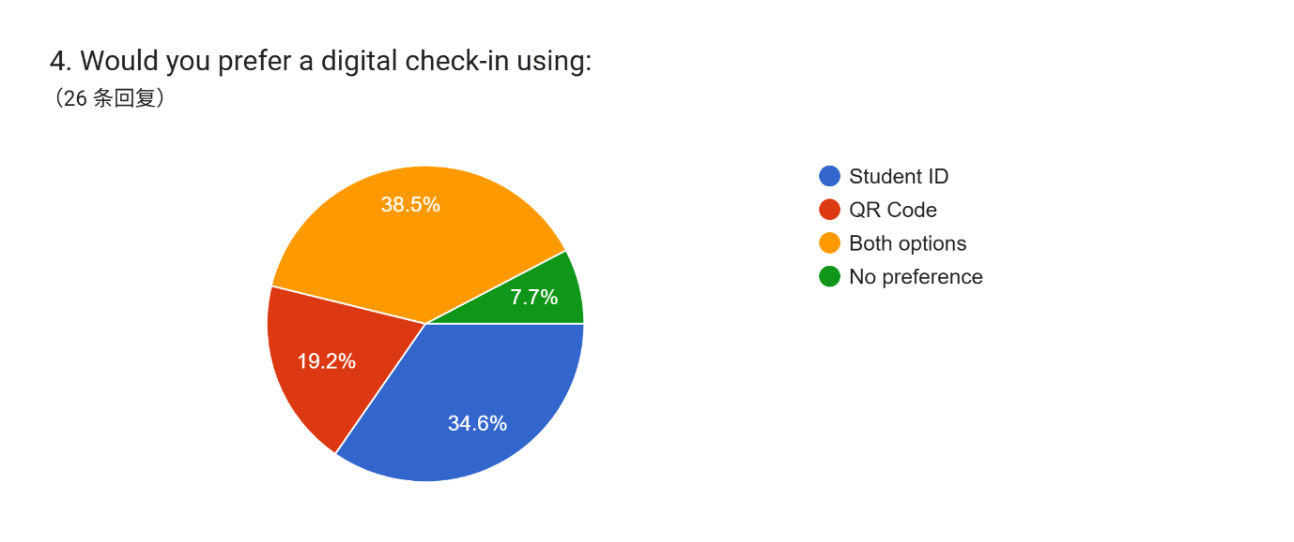

Figure 4.1.1 Preferred Check-In Method

1. What types of payment methods do you use/prefer?

A majority of respondents prefer (73.1%) e-wallets and (61.5%) Bank QR, supporting the need for integrated digital payment features in the system.

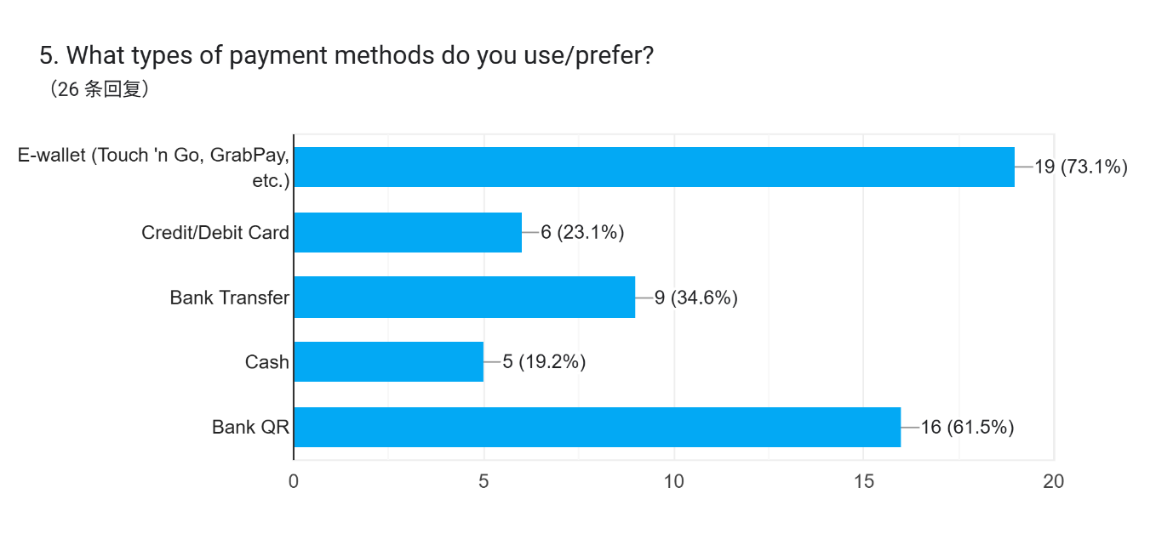

Figure 4.1.2 Preferred Payment Method

1. How helpful would it be to receive automated reminders and confirmations ?

How would you like to receive the notifications?

With 84.6% of respondents expecting confirmation messages, this supports the inclusion of automated email notifications (80.8%) after successful payment or registration.

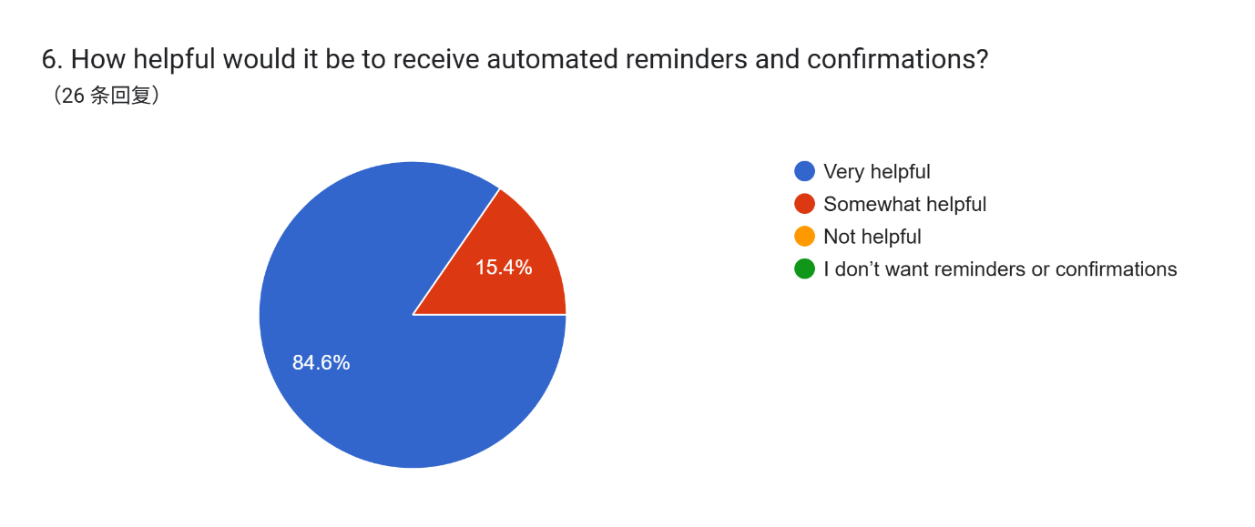

Figure 4.1.3 Automated Reminders and Confirmations

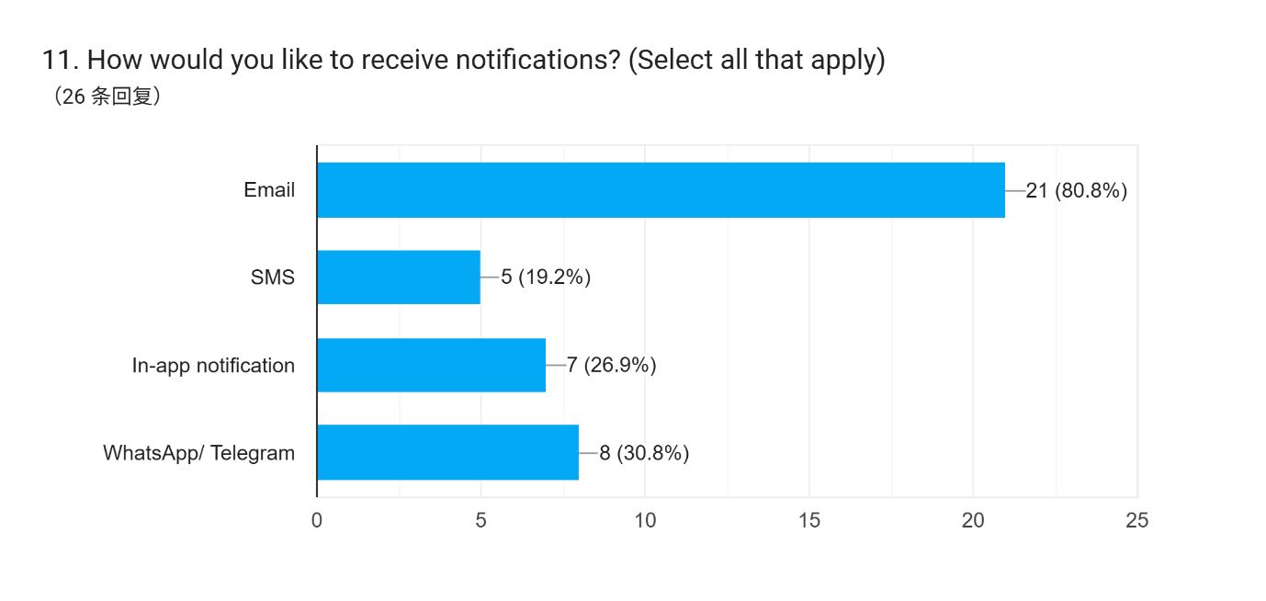

Figure 4.1.4 Method of Receive Notifications

1. Would calendar integration (Google/Outlook) be useful for reminders?

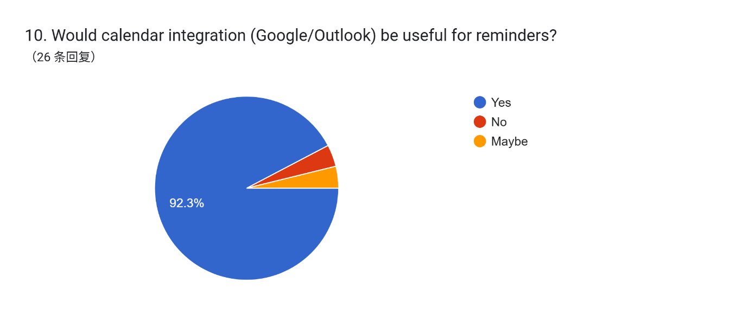

Figure 4.1.5 Interest in Event Reminder

1. Would you use a post-event rating or feedback feature?

76.9% said yes, confirming the desire for a post-event feedback system, a key performance feature for event organizers.

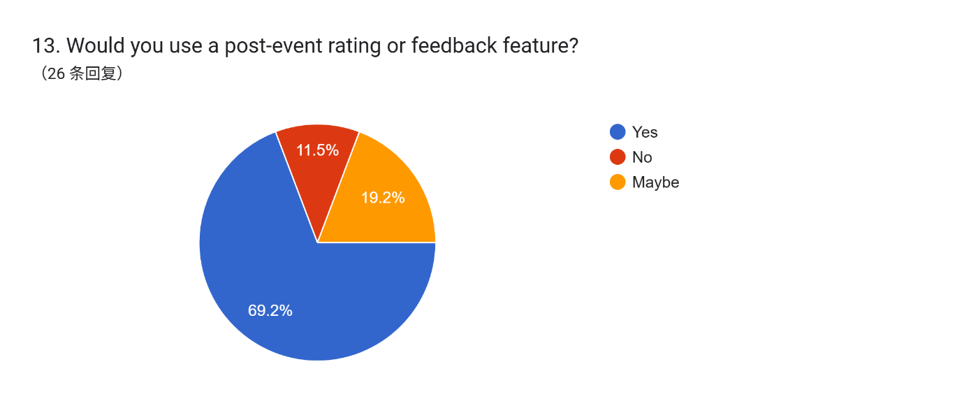

Figure 4.1.6 Interest in Post-event Rating and Feedback Feature

1. What features would make the system easier or more engaging for you?

This multi-select chart shows strong interest in features like QR code check-in, one-click registration, reminders, feedback, and payment integration — all performance-related needs. These responses helped prioritize core system functionalities.

In addition to performance needs, Q8 also revealed interest in event calendar integration and loyalty rewards, supporting the addition of Attractive Attributes (Delighters) such as calendar sync and gamified features.

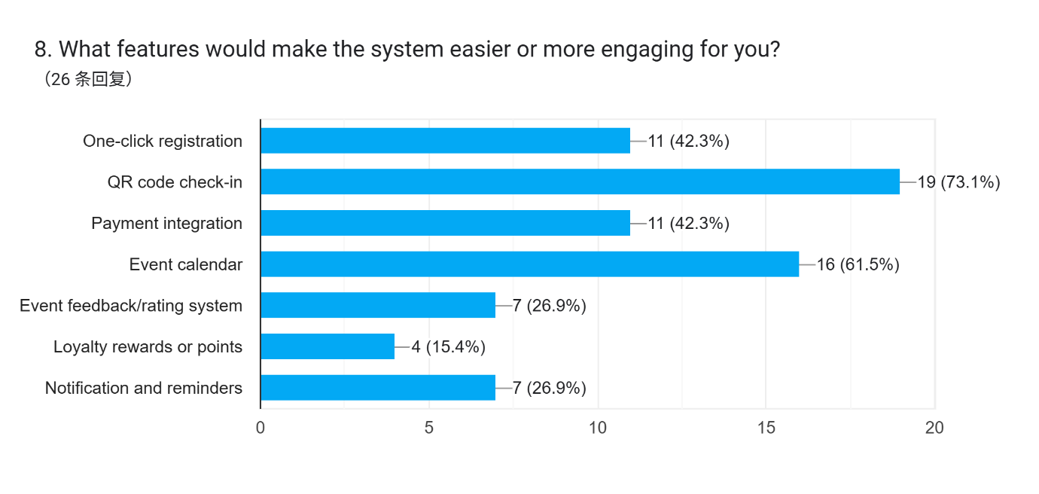

Figure 4.1.7 Top Performance Features Selected

1. Would a loyalty point or reward system motivate you to attend or manage more events?

69.2% of respondents are interested in a loyalty points system, validating this as a valuable “delighter” feature to increase engagement and reward regular participants.

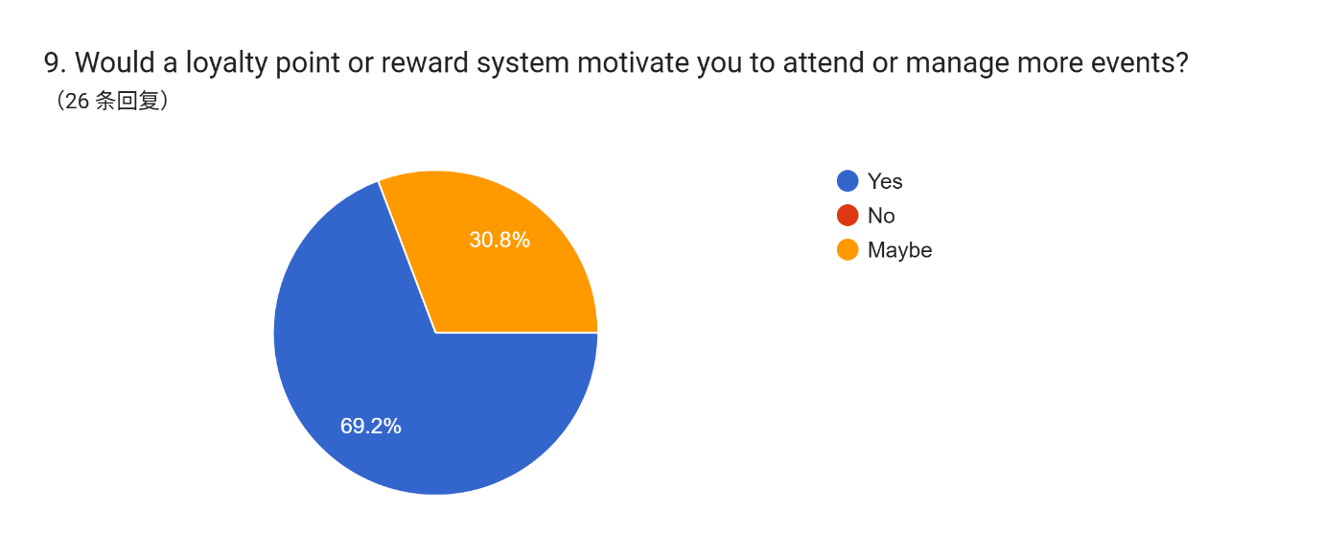

Figure 4.1.8 Interested in Loyalty point and Reward System

* 1. **Observation**

Observation was conducted by analyzing and comparing several real-world systems currently used in university environments or event platforms.

Observed Systems:

* Google Form-Based Manual Check-In

This is an example of a Google Form used for manual event check-in. Attendees scan a QR code that links to the form and manually enter their name, student ID, or email to register attendance.

This system is free and easy to use but prone to long queues, entry errors, and lacks identity verification.

Figure 4.2.1: QR code for Google Form

Figure 4.2.2: Manual Google Form-Based Check-In System

* Eventbrite Check-In System

Eventbrite offers a digital check-in app for organizers to scan QR codes from attendees' e-tickets. It supports real-time attendee management and integrates with event payment systems.

This system improves efficiency and accuracy but does not link with university student databases, which limits secure verification.

Figure 4.2.3 Eventbrite - Scan QR for Check-In and Event Payment System

* University RFID/Smart Card System

In this system, students tap their RFID-enabled student ID cards at event check-in points. The system is integrated with the university’s backend to verify identity and attendance records.

This method is fast, secure, and automated but requires infrastructure investment and integration with internal systems like finance and student ID databases.



Figure 4.2.5 RFID System in Universities

* 1. **Perspective-Based Reading (PBR)**

A total of four scholarly articles published between 2020 and 2024 were reviewed to support requirement elicitation through the lens of three stakeholder perspectives: Student, Organizer, and Admin. Key sentences from these articles directly influenced system requirement decisions.

PBR Articles and Sentence-Based Proof:

1. Mohd Akin et al. (2024):

“Students were dissatisfied with long queues and the lack of a digital confirmation after event check-in” (Mohd Akin et al., 2024).

Supports need for QR check-in and automated notifications.

1. Chaturvedi et al. (2024):

“CU-Events allows students to register and check in using a QR code while enabling organizers to view live participation data through a dashboard.”

Justifies performance needs such as dashboards and real-time monitoring.

1. Yang & Wen (2020):

“Virtual payment systems enhance user experience by allowing seamless transactions via QR code or mobile payment systems.”

Supports requirement for payment gateway integration and mobile compatibility.

1. Wang & Xu (2021):

“Virtual card systems must ensure integration with university records and support for financial traceability and data privacy.”

Justifies need for PDPA compliance and backend integration for admins.

* 1. **Brainstorming**

As part of our requirement elicitation process, an internal brainstorming session was carried out informally during one of our project group discussions. While a formal brainstorming document was not produced, the session was recorded in the meeting minutes, where the outcomes of the discussion on possible system-enhancing features.

* Documented in project meeting minutes.
* Feature outcomes cross-validated with questionnaire data.

1. **Conclusion**

The elicitation execution process for the Campus Event Check-In System was conducted using a combination of stakeholder-centered and research-based techniques. These included questionnaires, real-world system observation, perspective-based reading (PBR), and an internal brainstorming session. Each method provided valuable insights that contributed to a well-rounded understanding of user expectations and technical requirements.

The questionnaire, with 26 valid responses, provided strong validation for essential system features such as QR code/Student ID check-in, cashless payment options, event reminders, and feedback collection. It also revealed interest in additional engagement-focused features like loyalty points and event calendar sync, which were later categorized under Attractive Attributes (Delighters) in the Kano Model.

The observation of existing systems—such as Google Forms check-in, Eventbrite’s digital ticketing, and RFID student ID systems—helped identify both common practices and current limitations in check-in solutions. These findings supported the need for system automation, real-time tracking, and payment integration.

Through Perspective-Based Reading, scholarly articles further justified system requirements by highlighting best practices in digital check-in, student ID verification, and payment integration from various academic and institutional implementations.

Lastly, the brainstorming session, though informal, generated creative ideas like badges, leaderboards, and point redemption features that aligned with emerging user interests. These ideas were later validated through questionnaire responses.

All requirements were systematically categorized using the Kano Model to distinguish between Basic Attributes (Dissatisfiers), Performance Attributes (Satisfiers), and Attractive Attributes (Delighters). This classification allows the development team to prioritize features that are critical to user satisfaction while identifying value-added elements for future enhancement.

In conclusion, the elicitation techniques used in this project provided comprehensive, validated, and stakeholder-aligned requirements that form a strong foundation for designing a system that is not only functional but also engaging and future-proof.

1. **Reference**

Chaturvedi, A., Singh, A., & Yadav, A. (2024). CU-EVENTS: A comprehensive event management system for university. *International Journal for Research in Applied Science and Engineering Technology (IJRASET)*. <https://www.ijraset.com/research-paper/cu-events-a-comprehensive-event-management-system-for-university>

Mohd Akin, N. I. A., Othman, N., Bakar, S. A., & Saad, M. N. M. (2024). The development of mobile application for college event attendance system. *Journal of Mathematics and Computing Science*, 10(2). <https://journal.uitm.edu.my/ojs/index.php/JMCS/article/view/4265>

Wang, Y., & Xu, H. (2021). Research on campus card and virtual card information system. In *Proceedings of the 2021 International Conference on Wireless Communications, Networking and Applications* (pp. 1047–1053). Springer. <https://link.springer.com/chapter/10.1007/978-981-19-2456-9_117>

Yang, S., & Wen, L. (2020). Design and research of virtual payment system in colleges and universities. *Open Journal of Social Sciences*, 8(6), 232–241. <https://www.scirp.org/html/35-1763541_101114.htm>